
INT-002 AbsencePro, INT-005, 365 AIRES, INT-006 Allstate, INT-013 Cariloop, INT-014, 364 Certent, INT-015 Cigna, INT-016 COBRApoint, INT-COBRApoint, INT-077, 078, 261, 262 Fidelity, INT-088 Health Advocate, INT-095 Mutual of Omaha, INT-255 BCBS, INT-260 WEX, INT-237 SAP Minimaster, INT-238 SAP
System Integration Requirements & Design

Table of Contents
1 Platform Information 4
1.1 Contacts 4
1.2 Document Library 4
1.3 Dependencies and Risks 4
1.4 Success Criteria 5
2 Integrations Overview 5
2.1 Integrations in Scope 5
2.2 Functional Diagram 6
2.3 Integration Details 6
2.4 Data Flow Steps 7
3 Source System 8
3.1 System Integration Component Diagram 8
3.2 Key Assumptions 10
3.3 Connectivity Details 10
3.4 Source Data Mapping & Key Transformation Rules 12
3.5 Security Considerations 12
4 Destination System 13
4.1 System Integration Component Diagram 13
4.2 Key Assumptions 13
4.3 Destination Data Mapping 13
4.4 Destination Data Mapping: INT-238 SAP GL 13
4.5 Connectivity Details: Default 14
4.6 Connectivity Details: INT-237 SFTP / SAP Minimaster 15
4.6.1 EIH to Vendor SFTP Authentication: 15
4.7 Connectivity Details: INT-237 SAP Minimaster 15
4.7.1 Authentication 15
4.8 Connectivity Details: INT-238 SAP GL 17
4.8.1 SAP API Details 17
4.8.2 SAP Payload Example 17
4.8.3 Data Mapping 17
4.8.4 Error Handling 17
4.8.5 PGP 17
4.9 Key Transformation Rules 17
4.10 Security Considerations (all Integrations) 18
5 Enterprise Integration Hub 18
5.1 Integration Pattern: All Integrations 18
5.2 Integration Pattern: INT-237 SAP Minimaster 21
5.3 Integration Pattern: INT-238 SAP (GL) 21
5.4 Event Grid Integration Details: 27
5.5 Azure Function Receives Event and Retrieves Blob 27
5.6 Integration Design 28
5.7 Key Assumptions 29
5.8 Connectivity Details 31
5.9 Security Considerations 32
5.10 Test Data 34
5.11 Test Cases 34

Platform Information
To be completed and validated by the Digital Liaison.

Contacts
Business Owner(s) | Brian Frost bfrost@next-decade.com
Digital Liaison (s) | Shivareddy sdevarapalli@next-decade.com
Digital Technical Architect
Source SME or Vendor | Diana Sanchez diana.sanchez@workday.com
Destination SME or Vendor | Varies

Document Library
Document | Link
Requirements and Design Documentation Root Folder
SharePoint Library
FDS – Interface/endpoints

Dependencies and Risks
- Upstream Dependencies:
  - Workday System / Instance Availability: Integration Hub depends on Workday source for integration to Vendor SFTP, so a valid instance of Workday with Vendor SFTP connectivity endpoint is prerequisite for this integration.
  - Integration is moving data files from Workday Containers to Vendor SFTP.
- Downstream Dependencies:
  - Workday System / Instance Availability: The availability of the Vendor SFTP system is crucial for the successful integration with the Integration Hub.
- Known Risks:
  - Duplicate Data Files: In distributed systems, duplicate files data may be transmitted due to network retries. Therefore, receiving systems must ensure their operations are idempotent and capable of handling duplicate data effectively.
  - Dependency Downtime: Scheduled maintenance or upgrades in the upstream systems can result in temporary downtime of the integration flow, potentially impacting the near real-time integration requirements SLA.

Integrations Overview
The integration between Workday and Vendor SFTP is to ensure both systems stay in sync with the latest operational data files. Workday will provide updated source data files at recurring intervals.

Integrations in Scope
Destination Interface | Overview and Description
INT-002 -Workday – AbsencePro | Origin Workday: Census files
INT-005 -Workday – AIRES | Payroll File Outbound
INT-006 -Workday – Allstate | Voluntary Benefits
INT-013 -Workday -Cariloop | Origin Workday: Census files
INT-014 -Workday -Certent | CERTENT - Employees Demographic Full File Outbound
INT-015 -Workday -Cigna | CIGNA Medical Dental Vision Outbound
INT-016 -Workday -COBRApoint | COBRA Initial Rights Outbound
INT-017 -Workday -COBRApoint | COBRA Qualifying Events Outbound
INT-077 -Workday -Fidelity | Demographic Outbound
INT-078 -Workday -Fidelity | Contribution Oubtound
INT-088 -Workday -Health Advocate | Origin Workday: Census files
INT-095 -Workday -Mutual of Omaha | AD&D Enrollment, STD, LTD Enrollment
INT-255 -Workday -BCBS | BCBS Outbound
INT-260 -Workday -WEX | WEX CDEX Generic FSA HAS HRA Commuter Outbound
INT-261 -Fidelity -Workday | Loan Inbound
INT-262 -Fidelity 401k -Workday | 401k deferral elections
INT-364 -Workday -Certent | Payroll file Outbound
INT-365 -AIRES -Workday | Payroll inbound input relocation inbound
INT-237-Workday - SAP Minimaster | Mini-Master demographic data with PII
INT-238-Workday - SAP | GL payroll file

Functional Diagram
The integration between Workday and Vendor SFTP is to ensure both systems stay in sync with the latest operational data files. Workday will provide updated source data files at recurring intervals.
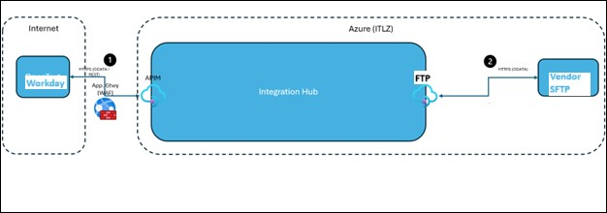

Figure 1: Sample functional diagram

Integration Details
Workday
Integration Attribute | Value
Integration Type (Pull / Push) | Workday -> Integration Hub: Push  Integration Hub -> Vendor SFTP: Push  Integration Hub -> Vendor SFTP: Pull
Data Exchange Methods Supported | Workday -> Integration Hub: Event-driven  Integration Hub -> Vendor SFTP(Push): Event-driven  Integration Hub -> Vendor SFTP (Pull): Timer trigger
Message Formats Supported | NA
Protocol Supported | SFTP (Port:22)
Authentication Methods Supported | Workday -> Integration Hub: SSH Keys  Integration Hub -> Vendor SFTP: SFTP passwords, SSH private keys from Key Vault.
Frequency Required | Real-time – when file gets created
Data Transfer Method (Synchronous/Asynchronous) | Workday -> Integration Hub: Asynchronous  Integration Hub -> Vendor SFTP: Asynchronous

Data Flow Steps
Provide the data flow steps the process requires for Workday to Vendor SFTP (Push).
Step 1 | Workday uploads the file to Blob Storage container using SSH keys.
Step 2 | An event to the Event Grid is created.
Step 3 | Event Grid then sends the file to Service Bus which has Azure Function App subscription to retrieve the SFTP configuration password/ SSH private key from the Key Vault.
Step 4 | Then the file uploaded to Vendor SFTP using password/SSH private key from Key Vault.
Step 5 | On Success, the message will be logged in to the Integration Dashboard.
Step 6 | On Failure, 4 file uploads retry happens and the same logged in the Integration Dashboard.

Provide the data flow steps the process requires for Vendor SFTP to Workday (Pull).
Step 1 | Vendor SFTP uploads file to the specified SFTP location.
Step 2 | Using timer trigger, the Azure function pulls the file from SFTP location to blob storage with password/SSH private key from Key Vault.
Step 3 | With SSH authentication, Workday pull the file from the blob storage of respective container
Step 4 | Result will be logged in to the Integration Dashboard.

Source System: Workday

System Integration Component Diagram
Workday will send files to the integration hub for delivery to the vendors. A limited number of vendors will also send files back to Workday through the integration hub. The following diagrams show the SFTP Push from Workday to the EIH and then to the Vendors and the SFTP Pull from the Vendors to the EIH and then to Workday.
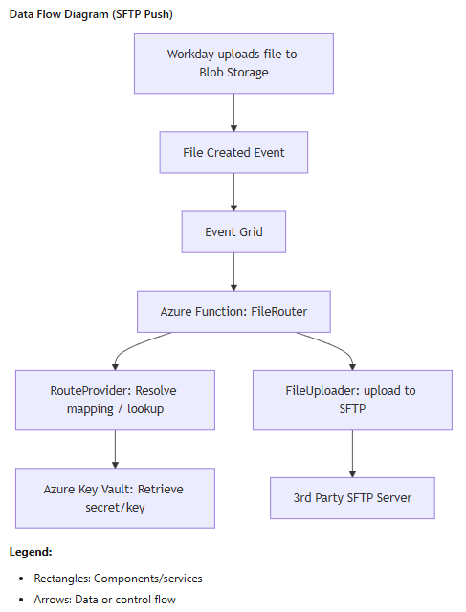

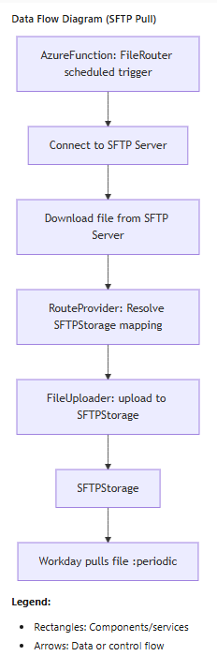

Key Assumptions
- Each vendor only has access to their data and cannot access any other vendor data.
- Workday will send files to EIH for delivery to the vendor. Workday sends files using SFTP.
- Workday may encrypt files using PGP for delivery to the vendor.
- File is sent to vendor for each integration

Connectivity Details
Workday will connect to blob storage with an SFTP username for each vendor. The following table includes the connectivity endpoint for each vendor.
Integration | Connectivity Endpoint
INT-2 Workday - AbsencePro | steihsftpdevscus.sftpworkdayabsencepro@steihsftpdevscus.blob.core.windows.net
INT-5 Workday - AIRES | steihsftpdevscus.sftpworkdayaires@steihsftpdevscus.blob.core.windows.net
INT-6 Workday - Allstate | steihsftpdevscus.sftpworkdayallstate@steihsftpdevscus.blob.core.windows.net
INT-13 Workday - Cariloop | steihsftpdevscus.sftpworkdaycariloop@steihsftpdevscus.blob.core.windows.net
INT-14 Workday - Certent | steihsftpdevscus.sftpworkdaycertent@steihsftpdevscus.blob.core.windows.net
INT-15 Workday - Cigna | steihsftpdevscus.sftpworkdaycigna@steihsftpdevscus.blob.core.windows.net
INT-16 Workday - COBRArights | steihsftpdevscus.sftpworkdaycobrarights@steihsftpdevscus.blob.core.windows.net
INT-17 Workday - COBRAQE | steihsftpdevscus.sftpworkdaycobraqe@steihsftpdevscus.blob.core.windows.net
INT-77 Workday - FidelityDemo | steihsftpdevscus.sftpworkdayfidelitydemo@steihsftpdevscus.blob.core.windows.net
INT-78 Workday - FidelityContrib | steihsftpdevscus.sftpworkdayfidelitycontrib@steihsftpdevscus.blob.core.windows.net
INT-88 Workday - HealthAdvocate | steihsftpdevscus.sftpworkdayhealthadvocate@steihsftpdevscus.blob.core.windows.net
INT-95 Workday - MutualofOmaha | steihsftpdevscus.sftpworkdaymutualofomaha@steihsftpdevscus.blob.core.windows.net
INT-255 Workday - BCBS | steihsftpdevscus.sftpworkdaybcbs@steihsftpdevscus.blob.core.windows.net
INT-260 Workday - WEX | steihsftpdevscus.sftpworkdaywex@steihsftpdevscus.blob.core.windows.net
INT-261 FidelityLoan - Workday | steihsftpdevscus.sftpfidelityloanworkday@steihsftpdevscus.blob.core.windows.net
INT-262 Fidelity401k - Workday | steihsftpdevscus.sftpfidelity401kworkday@steihsftpdevscus.blob.core.windows.net
INT-364 Workday - CertentPayroll | steihsftpdevscus.sftpworkdaycertentpayroll@steihsftpdevscus.blob.core.windows.net
INT-365 AIRES - Workday | steihsftpdevscus.sftpairesworkday@steihsftpdevscus.blob.core.windows.net
INT-237 Workday - SAPMinimaster | steihsftpdevscus.sftpworkdaysapminimaster@steihsftpdevscus.blob.core.windows.net
INT-238 Workday - SAPGL | steihsftpdevscus.sftpworkdaysapgl@steihsftpdevscus.blob.core.windows.net

In addition, each vendor will have a separate container within the blob. The following table contains the container and home directory of each vendor.
Integration | Container | Home Directory
INT-2 Workday - AbsencePro | absencepro | /
INT-5 Workday - AIRES | aires | inbound, outbound, inboundtest, outboundtest
INT-6 Workday - Allstate | allstate | /
INT-13 Workday - Cariloop | cariloop | cariloop
INT-14 Workday - Certent | certent | /
INT-15 Workday - Cigna | cigna | cigna
INT-16 Workday - COBRArights | cobrarights | cobrarights
INT-17 Workday - COBRAQE | cobraqe | cobraqe
INT-77 Workday - FidelityDemo | fidelitydemo | fidelitydemo
INT-78 Workday - FidelityContrib | fidelitycontrib | fidelitycontrib
INT-88 Workday - HealthAdvocate | healthadvocate | /
INT-95 Workday - MutualofOmaha | mutualofomaha | /
INT-255 Workday - BCBS | bcbs | inbound, outbound
INT-260 Workday - WEX | wex | /
INT-261 FidelityLoan - Workday | fidelityloan | fidelityloan
INT-262 Fidelity401k - Workday | fidelity401k | fidelity401k
INT-364 Workday - CertentPayroll | certentpayroll | /
INT-365 AIRES - Workday | aires | /
INT-237 Workday - SAPMinimaster | sapminimaster | sapminimaster
INT-238 Workday - SAPGL | sapgl | sapgl

Source Data Mapping & Key Transformation Rules
There is no data mapping or transformation. Workday is sending a file, often encrypted, to the EIH for delivery to the vendor.

Security Considerations
Workday will provide an SSH public key for import into the sftp username to support authenticating to the sftp folder in blob storage. The EIH will provide an SSH key to each vendor to establish connection to the vendors SFTP server.
The following figure is an example.
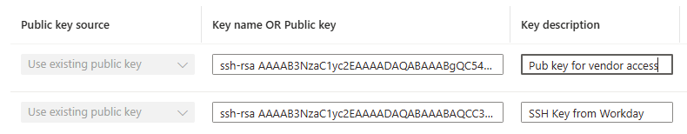

Destination System:

All Vendors
Workday sends files to Vendor SFTP through Integration Hub. The EIH does not open the files or perform any transformations.

SAP (INT 237 & INT 238)
INT-237: Workday è SAP HR Minimaster:
The HR Mini Master is a subset of employee master data in SAP

INT-238: Workday è SAP GL Posting

Key Assumptions
Any assumptions about the destination that would impact the integration: i.e., destination is not available after hours, volume, frequency, security, etc.

Destination Data Mapping
There is no data mapping or transformation for most vendors. Workday is sending a file, often encrypted, to the EIH for delivery to the vendor.

Destination Data Mapping: INT-238 SAP GL
Please refer to the Mapping document below for Transformation rules:
Mapping / Transformation
INT-238 Workday to SAP GL Mapping document | GL Posting Mapping WorkDay and SAP.xlsx

Connectivity Details: Default
EIH has generated a unique SSH key pair (private and public) for each vendor. The public key is shared with the respective vendor, who configures their SFTP server to allow access using this key. EIH then uses the corresponding private key to authenticate itself when connecting to the vendor's SFTP server, enabling secure and authorized file transfers (both pull and push operations) with vendor endpoints.
Below is the list of Workday and Vendors Connectivity Details which includes:
- EIH Blob Storage Account Details
- Public Keys
- Vendor SFTP Folders, Connectivity and User Details.
Connectivity details are also contained in the Workday internal document.
Integration name | SFTP Host | Directory
INT-005 -Workday -AIRES | dmzserv.aires.com | Directory to place staging files: ./inboundtest  Directory to pull staging files: ./outboundtest  Directory to place production files: ./inbound  Directory to pull production files: ./outbound
INT-365 -AIRES -Workday | dmzserv.aires.com | Directory to place staging files: ./inboundtest  Directory to pull staging files: ./outboundtest  Directory to place production files: ./inbound  Directory to pull production files: ./outbound
INT-014 -Workday -Certent | sftpecho.certent.com/ | ROOT
INT-364 -Workday -Certent | sftpecho.certent.com/ | ROOT
INT-095 -Workday -Mutual of Omaha | 170.31.64.187 | test
INT-255 -Workday -United Health Care | ecgpe.healthtechnologygroup.com | /in/NEXTDECUSP/CIP/adop
INT-002 -Workday -AbsencePro | eft.compsych.com
INT-006 -Workday -Allstate | awdsftp.allstateatwork.com (167.127.100.186) | /
INT-013 -Workday -Cariloop | ftp.cariloop.com | /test folder
INT-015 -Workday -Cigna | sftp-b2bgateway.sys.cigna.com | Outbox
INT-016 -Workday -COBRA QE | sftp-directmft.wexhealthinc.com | N/A
INT-017 -Workday -COBRA Rights | sftp-directmft.wexhealthinc.com | N/A
INT-077 -Workday -Fidelity
INT-078 -Workday -Fidelity
INT-088 -Workday -Health Advocate | sftp.healthadvocate.net | root
INT-260 -Workday -WEX | sftp-directmft.wexhealthinc.com | /
INT-261 -Fidelity -Workday
INT-262 -Fidelity 401k -Workday

Connectivity Details: INT-237 SFTP / SAP Minimaster

Connectivity Details: INT-237 SAP Minimaster

- [Integration Team-Adi]-EIH to give you the credentials (Password or key) and the sftp location to get the files [ETC 10/17]
- [SAP Team-Vamsi]-SAP to provide the PGP public key to workday so they can encrypt that using that
- SFTP Username steihsftpdevscus.sftpworkdaysapminimaster
- SFTP Account sftpsapminimasterworkday
- Connectivity Endpoint steihsftpdevscus.sftpworkdaysapminimaster@steihsftpdevscus.blob.core.windows.net
- Container sapminimaster

Authentication
Authentication Mechanism between Workday, EIH and Vendor SFTP
The authentication mechanism is designed to ensure secure and seamless file transfers between the Source system (Workday) and multiple destination vendors SFTP. The authentication setup follows a key-based approach to guarantee confidentiality and integrity of the data.Workday to EIH Authentication:
Workday is the source system, provides us with a unique public SSH key for each vendor. This key allows Workday to access files into vendor-specific blob folders within EIH network. The EIH platform uses these public keys to authenticate and authorize incoming connections from Workday, ensuring that only Workday can access or copy files in the designated vendor folders.

File Encryption and Transfer Mechanism between Workday, EIH and SAP.
- Workday File Generation and PGP Encryption:
  - SAP provides its PGP public keys to Workday and EIH, which are used to encrypt files before sending.
  - Workday generates a file named Minimaster CSV.pgp. The .pgp extension indicates that the file is encrypted using PGP (Pretty Good Privacy) encryption.
  - PGP encryption uses a pair of keys: a public key for encrypting data and a private key for decrypting it. This ensures that only authorized parties with the correct private key can read the file contents.
  - In this case, Workday uses the PGP public key (provided by SAP) to encrypt the file, ensuring that only SAP can decrypt it. Workday then sends these encrypted files to EIH.
  - EIH then sends the Encrypted File to SAP using SSH Key for Authentication with SAP.
- Authenticate Workday using SSH Key:
  - Additionally, Workday shares its own public key with EIH, which allows EIH to verify the authenticity of files sent by Workday.
- Get Authenticated with SAP using SSH Key:
  - EIH holds SSH key pairs (private and public) to authenticate and transfer files securely to SAP's SFTP server, labeled as al11.
  - EIH uses its private key to authenticate when pushing files to the SAP SFTP server.
  - The SAP SFTP server has EIH’s public key configured, allowing it to verify EIH's identity and permit secure file transfer.
  - SAP provides connection details like SFTPHOST and SFTP User to EIH for establishing this SFTP communication.
  - EIH will create SSH key pairs for SAP (Mini Master) and will issue that private key to SAP, so SAP can fetch the file from EIH’s SFTP server. This can also be accomplished by username and password as well. Where the password will be shared with SAP Minimaster to connect to EIH’s SFTP server.

Connectivity Details: INT-238 SAP GL

SAP API Details
To be provided by Vamsi. Include the endpoint for the different environments and the Authentication, Authorization.

SAP Payload Example

Data Mapping
Include mapping details

Error Handling
[SAP Team-Vamsi]-Error handling and edge cases for recovery and notifications

PGP

Key Transformation Rules: INT-238 SAP GL
List source to destination data mapping and transformation details. May reference the mapping and transformation document on SharePoint. (If any)
CC TSS - Payroll GL Journals Outbound - Design Document.xlsx

Security Considerations (all Integrations)
Provide any security considerations such authentication (Tokens, Basic, etc.), authorization / RBAC, data encryption (TLS, etc.), Network (Ports), Secrets, Data Access etc. (If any)

Enterprise Integration Hub
Enterprise Integration Hub: This section discusses the integration hub and its components. Additionally, it presents a high-level design diagram of the system, details the components involved in Azure integration, and includes information on data transformation, security and connectivity.

Integration Pattern: All Integrations
This pattern applies to all integrations, except INT-237 and INT-238. See section Integration Pattern: INT-238 SAP (GL) for those. The following figure describes the SFTP Push process, which is also detailed in ND Integration Hub Wiki. See the Workday File & Routing section for more details of the Integration pattern.
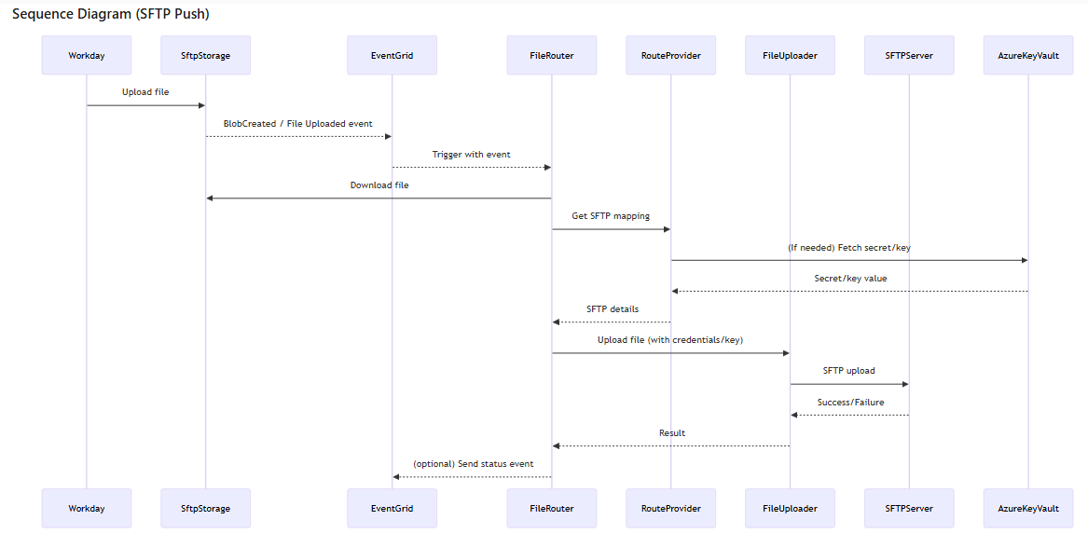
SFTP Push
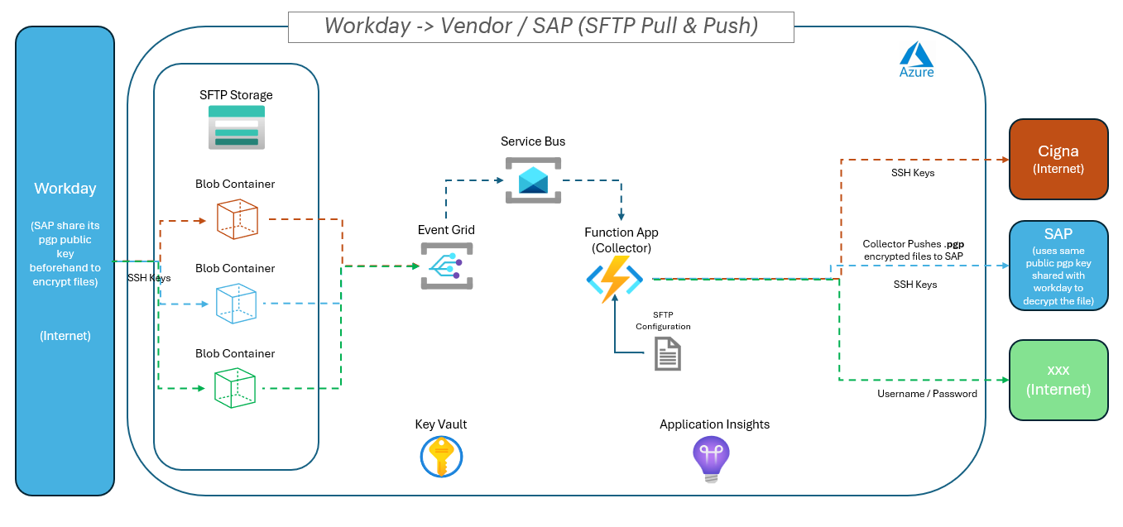
The key components involved in the above integration are as follows:
- Workday (Source System): After SSH authentication, Workday places file in the Blob storage.
- Event Grid pushes this file from blob storage to Service bus. Then this service bus triggers a function named “WorkdayFileManagement”. This function retrieves SFTP config along with password/SSH private key from Key vault.
Key Vault and other integration details are as below
- Azure Key Vault Integration:
- Store secrets in Key Vault:
- Add SFTP passwords or SSH private keys as secrets in your Azure Key Vault. Example secret names: sftp-consumer1-password, sftp-consumer2-key.
- Reference secrets in config: - In the SftpConfig.json, set the value to azurekeyvault:<secret-name> for Password or SshPrivateKeyPath fields.
- Example:
{
"sftpConfig": [
{
"host": "sftp1.example.com",
"port": 22,
"User": "user1",
“Directory”: “directory1”,
" PasswordKeyVaultSecretName ": "azurekeyvault:sftp-consumer1-password",
" SshKeyPassphraseKeyVaultSecretName ":"",
" SshPrivateKeyKeyVaultSecretName ":""
}
,
{
"host": "sftp2.example.com",
"port": 22,
"User": "user2",
“Directory”: “directory2”,
" PasswordKeyVaultSecretName ": "azurekeyvault:sftp-consumer2-password",
" SshKeyPassphraseKeyVaultSecretName ":"",
" SshPrivateKeyKeyVaultSecretName ":""
}
]
}
- Configure environment:
Set the environment variable KEY_VAULT_URL to the Key Vault URI (e.g., https://myvault.vault.azure.net/).
- Managed Identity:
The Function App must have access to Key Vault (via Managed Identity or Service Principal with permission for secrets).
SFTP Pull
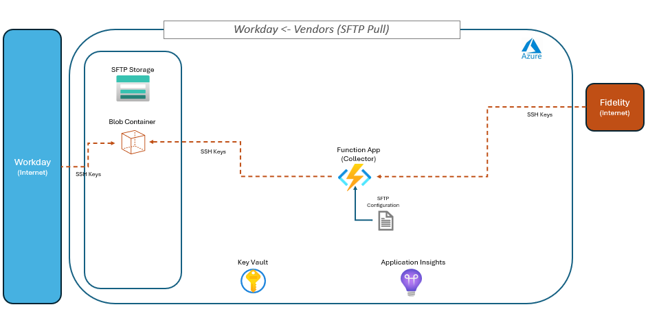
The Authentication Mechanism using SSH key will remain same in Pull Method as well. Only the data flow will change. The key components involved in the above integration are as follows:
- Vendor SFTP (Source System): The file will be placed in the Vendor’s respective SFTP folder.
- Integration Hub: A timer trigger will monitor the SFTP for any new file uploaded to Vendor SFTP. Then Azure function, will connect to SFTP using SFTP config with password/SSH private key from Key Vault, pull and place the file to the blob storage.
- Workday (Destination system) : After SSH authentication, Workday will pick the file from the blob storage.

Integration Pattern: INT-237 SAP Minimaster

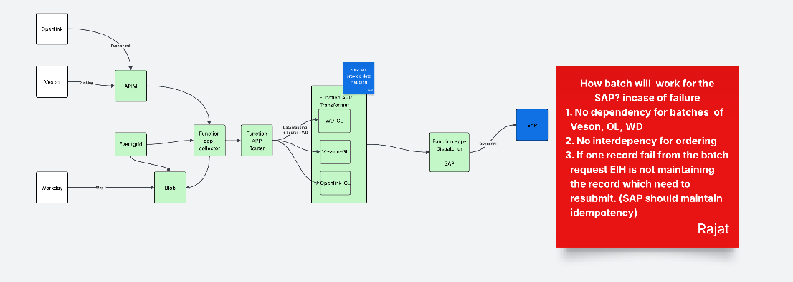

Integration Pattern: INT-238 SAP (GL)
The GL integration will use the SAP SOAP API rather than an OData call. The call will be certificate based. The SAP team will provide the API.
SAP GL Integration will have one additional step at Enterprise Integration Hub. EIH will also have the pgp key to decrypt the file and perform the transformation before sending the Data to SAP.
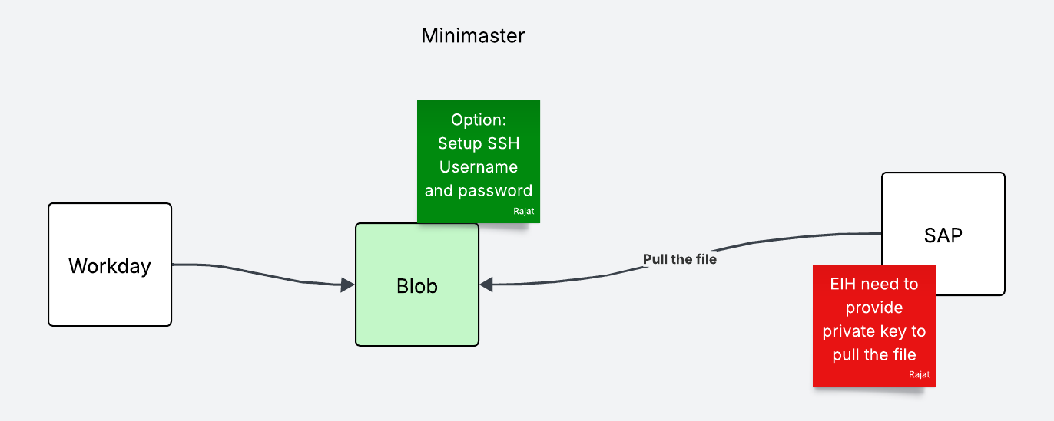

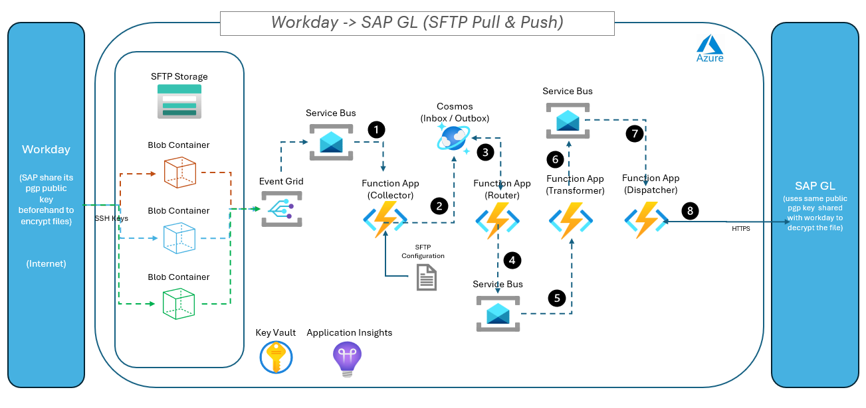
Workflow: File Encryption and Transfer Mechanism between Workday, EIH and SAP.
- Workday File Generation and PGP Encryption:
  - SAP provides its PGP public keys to Workday and EIH, which are used to encrypt files before sending.
  - Workday generates a file named Minimaster CSV.pgp. The .pgp extension indicates that the file is encrypted using PGP (Pretty Good Privacy) encryption.
  - PGP encryption uses a pair of keys: a public key for encrypting data and a private key for decrypting it. This ensures that only authorized parties with the correct private key can read the file contents.
  - In this case, Workday uses the PGP public key (provided by SAP) to encrypt the file, ensuring that only SAP can decrypt it. Workday then sends these encrypted files to EIH. NOTE: for INT-238 (GL) SAP will have to provide its PGP private key to EIH, so EIH can decrypt the file on SAP’s behalf and transform the payload attributes.
- Authenticate Workday using SSH Key:
  - Additionally, Workday shares its own public key with EIH, which allows EIH to verify the authenticity of files sent by Workday.
- Get Authenticated with SAP using OData API:
  - EIH Authenticates with SAP using ODATA Api before it allows access to their System.

The key components involved in the above integration are as follows:
- Workday (Source System): After SSH authentication, Workday places file in the Blob storage.
- ` Event Grid pushes this file from blob storage to Service bus. Then this service bus triggers a function named “workday-workorder-collect”. This function retrieves file Destination details config along with password/secret from Key vault.

Key Vault and other integration details are as below
- Example:
{
"sftpConfig": [
{
"host": "sftp1.example.com",
"port": 22,
"User": "user1",
“Directory”: “directory1”,
" PasswordKeyVaultSecretName ": "azurekeyvault:sftp-consumer1-password",
" SshKeyPassphraseKeyVaultSecretName ":"",
" SshPrivateKeyKeyVaultSecretName ":""
}
,
{
"host": "sftp2.example.com",
"port": 22,
"User": "user2",
“Directory”: “directory2”,
" PasswordKeyVaultSecretName ": "azurekeyvault:sftp-consumer2-password",
" SshKeyPassphraseKeyVaultSecretName ":"",
" SshPrivateKeyKeyVaultSecretName ":""
}
]
}
- Configure environment:
Set the environment variable KEY_VAULT_URL to the Key Vault URI (e.g., https://myvault.vault.azure.net/).
- Managed Identity:
The Function App must have access to Key Vault (via Managed Identity or Service Principal with permission for secrets).
}
- Collector also validates the request, hydrates the integration event with metadata and persists that into the Cosmos (Inbox). Refer to the following Collector Wiki link for more details: Collector App - Overview. A sample json of the persisted payload is shown below (NOTE: the below sample is for GL filesmanagement payloads)
- "Correlationld": " b3e1a2ca-5d6f-aa7b-8c9d -123456789abc",
"Source": "workday",
"IntegrationType": " filesmanagement",
"Timestamp": "",
"ClaimCheck": true,
"payload": {
[ {
}]
},
"Version": "1.0"
}

- Integration Hub Router App: Processes the in-boxed event and hydrates it with the routing-slip information and persists that into outbox, which is again processed by the router and dispatched to the first topic “workday-filesmanagement-sap-transform” in the route. Additional details of the Router App are provided in the ND Integration Hub Wiki Router App - Overview
A sample json of the routing-slip lookup and persisted event is shown below:
{
"id": "workday-workorder",
"source" : "workday",
"type": " filesmanagement ",
"routingSlip": {
"routes": [
{
"destination":"sap",
"topics": [
"workday- filesmanagement -sap-transform",
" workday - filesmanagement -sap-dispatch"
]
},
{
"destination":"datalake",
"topics": [
"workday- filesmanagement -datalake-transform",
" multisource-multiintegration-datalake-dispatch"
]
}
]
}
}
======================================================================================
{
"Correlationld": " b3e1a2ca-5d6f-aa7b-8c9d -123456789abc",
"Source": "workday",
"IntegrationType": " filesmanagement ",
"Timestamp": "",
"ClaimCheck": true,
"payload": {
[{
} ]
},
“Destination”:”sap”,
“Routes”: [
" workday - filesmanagement -sap-transform",
" workday - filesmanagement -sap-dispatch"
] ,
“RetryCount”: 0,
"Version": "1.0"
}

{
"Correlationld": " b3e1a2ca-5d6f-aa7b-8c9d -123456789abc",
"Source": "workday",
"IntegrationType": " workorder",
"Timestamp": "",
"ClaimCheck": true,
"payload": {
[{
} ]
},
“Destination”:”datalake”,
“Routes”: [
"workday- filesmanagement-datalake-transform",
" multisource-multiintegration-datalake-dispatch"
] ,
“RetryCount”: 0,
"Version": "1.0"
}

- Integration Hub Transformer App: The transformer app subscribes to the “workday-workorder-sap-transform” topic where the event is published by the router and after receiving the message, unwraps the payload (using the public pgp key provided by SAP). It will download the file using claim-check and execute the transformation logic (Refer to the data mapping source and target message examples for data structures and field map for transformation logic). The file will be copied to our transform directory and passed as claim-check to the next topic on the route. Any error during transformation would be a non-retriable error and should be logged in detail (unless it’s connected to an external API and if there is a transient error, then it should be retriable via Integration Hub Monitor App). Additional information about the Dispatcher App are on the ND Integrated Hub Wiki Transformer App - Overview

- Integration Hub Dispatcher App: The dispatcher app subscribes to the “workday-workorder-sap-dispatch” topic where the event is published by the transformer and after receiving the message, unwraps the payload and executes the ODATA query against the configured SAP API endpoint. Transient errors are retried and should be escalated to Retry topic where the Integration Hub Monitor App retries for the configured number of times after which the error is escalated and logged into Application Insights. Refer to the target message example for data payload to be sent to SAP. Additional information about the Dispatcher App are on the ND Integrated Hub Wiki Dispatcher App - Overview.
Include section about data lake dispatcher for INT-238

Event Grid Integration Details:
Event Grid Subscription from Storage
- System Topic Name Example: workday-filemanagement
- System Topic Subscriber Name Example: workday-filemanagement-subscriber
- Description:
  - The Storage Account is configured to send BlobCreated events to an Azure Event Grid Custom Topic via an Event Grid Subscription.
- Required Role for Storage Account:
  - EventGrid Data Sender (on the Storage Account, to emit events)
Forwarding Event Grid Events to Service Bus Topic
- Description:
- The Event Grid System Topic is configured with an Event Subscription that forwards events to a Service Bus Topic.
- System Topic Name Example: workday-filemanagement-collect
- System Topic Subscriber Name Example: workday-filemanagement-collect-subscriber
- Required Role for Service Bus Topic:
- Azure Service Bus Data Sender (for Event Grid to send messages to the Service Bus Topic)

Azure Function Receives Event and Retrieves Blob
- Description:
- The Azure Function is triggered by the Service Bus Topic event, processes the event, and retrieves the referenced blob from the Storage Account.
- Required Role for Azure Function:
- Storage Blob Data Contributor (on the Storage Account or specific container, to read/download blobs)
Note:
Assign these roles to the managed identities of the respective resources (Storage Account, Event Grid Topic, Service Bus, Azure Function) for secure, least-privilege access.

Integration Design
To be completed by Integration Team with input from Vendor Technical SMEs.
- Frequency (Delivery Compliance to Azure)
- Key Assumptions
- Security Considerations
SFTP will use SSH Key Pairs stored in Azure Key Vault to secure access to the Blob storage. A separate container is created for each integration to limit access to only the integration and not any additional folders.
- Data Mapping & Transformation Rules
None. Workday is sending an encrypted file to the EIH, which will be sent/picked up by the target vendor.
- Connectivity End Point
- High Level Design Diagram
- Azure Integration Components
Attribute | Value
Data Exchange Method | Event-Driven, Timer trigger
Message Format | NA
Protocol | SFTP (Port:21)
Authentication | Password/SSH private key from Key Vault
Frequency | Real-time – when file gets created
Synchronous/Asynchronous | Synchronous
Additional Details | NA

Source Message Format details:
Message Name | Description | Request Format | Response Format
[Message Type] | [Purpose of the message] | [Example Request Format] | [Example Response Format]
NA | NA | NA | NA

Target Message Format details:
Message Name | Description | Request Format | Response Format
[Message Type] | [Purpose of the message] | [Example Request Format] | [Example Response Format]
NA | NA | NA | NA

Key Assumptions
- A local user account will be created for each vendor/integration and mapped to a separate container.
- Subfolders may be created within the container to align with requirements, ie, Inbound, Outbound, home, etc.
- 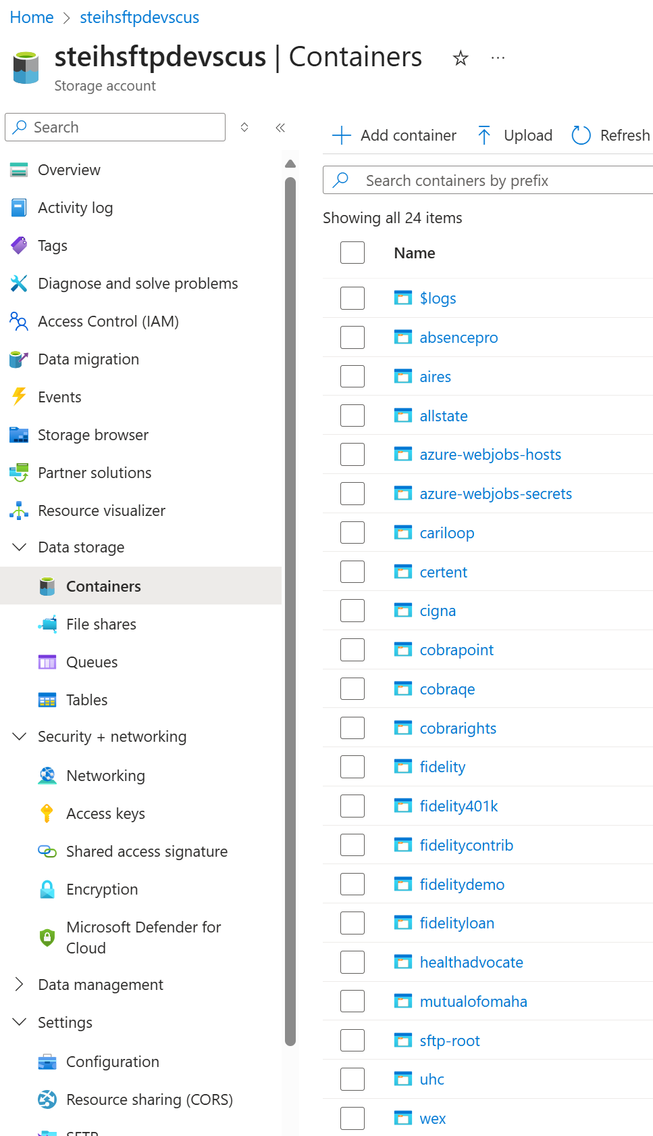
Figure 2: Initial containers created for Workday
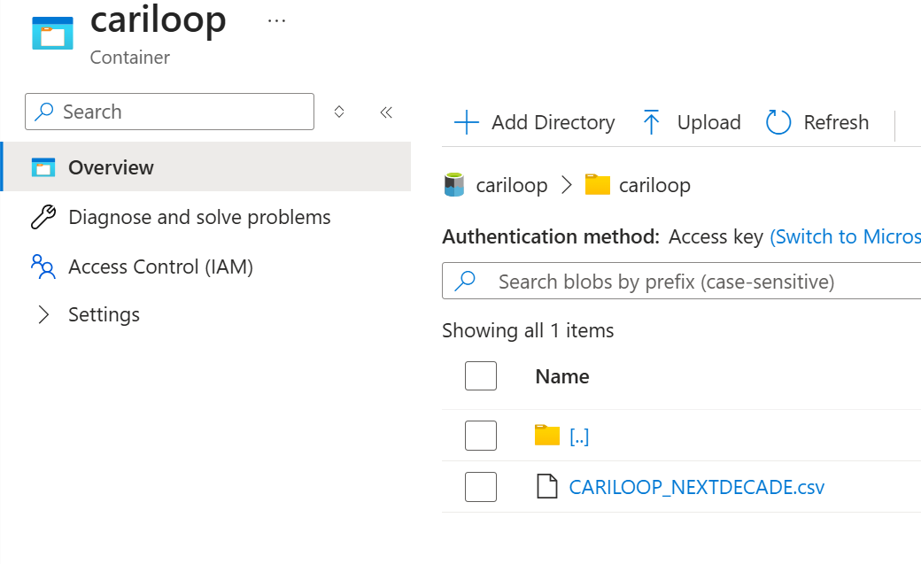
Figure 3: Example subfolder

Connectivity Details
Integration Number | Local SFTP Account Source | Container | Authentication | Home Directory
INT-13 | sftpworkdaycariloop | cariloop | SSH Key Pair | cariloop
INT-14 | sftpworkdaycertent | certent | SSH Key Pair | certent
INT-15 | sftpworkdaycigna | cigna | SSH Key Pair | cigna
INT-16 | sftpworkdaycobrarights | cobrarights | SSH Key Pair | cobrarights
INT-17 | sftpworkdaycobraqe | cobraqe | SSH Key Pair | cobraqe
INT-2 | sftpworkdayabsencepro | absencepro | SSH Key Pair | absencepro
INT-255 | sftpworkdaybcbs | bcbs | SSH Key Pair | bcbs
INT-260 | sftpworkdaywex | wex | SSH Key Pair | wex
INT-261 | sftpworkdayfidelityloan | fidelityloan | SSH Key Pair | fidelityloan
INT-262 | sftpworkdayfidelity401k | fidelity401k | SSH Key Pair | fidelity401k
INT-364 | sftpworkdaycertentpayroll | certent | SSH Key Pair | certent
INT-365 | sftpairesworkday | aires | SSH Key Pair | aires
INT-5 | sftpworkdayaires | aires | SSH Key Pair | aires
INT-6 | sftpworkdayallstate | allstate | SSH Key Pair | allstate
INT-77 | sftpworkdayfidelitydemo | fidelitydemo | SSH Key Pair | fidelitydemo
INT-78 | sftpworkdayfidelitycontrib | fidelitycontrib | SSH Key Pair | fidelitycontrib
INT-88 | sftpworkdayhealthadvocate | healthadvocate | SSH Key Pair | healthadvocate
INT-95 | sftpworkdaymutualofomaha | mutualofomaha | SSH Key Pair | Mutualofomaha
INT-237 | sftpWorkdaySAPMinimaster | sapminimaster | SSH Key Pair | sapminimaster
INT-238 | sftpWorkdaySAPGL | sapgl | SSH Key Pair | sapgl

Integration Number | Connectivity Endpoint
INT-13 | sftpworkdaycariloop.sftpuser@steihsftpdevscus .blob.core.windows.net
INT-14 | sftpworkdaycertent.sftpuser@steihsftpdevscus .blob.core.windows.net
INT-15 | sftpworkdaycigna.sftpuser@steihsftpdevscus .blob.core.windows.net
INT-16 | sftpworkdaycobrarights.sftpuser@steihsftpdevscus .blob.core.windows.net
INT-17 | sftpworkdaycobraqe.sftpuser@steihsftpdevscus .blob.core.windows.net
INT-2 | sftpworkdayabsencepro.sftpuser@steihsftpdevscus .blob.core.windows.net
INT-255 | sftpworkdaybcbs.sftpuser@steihsftpdevscus .blob.core.windows.net
INT-260 | sftpworkdaywex.sftpuser@steihsftpdevscus .blob.core.windows.net
INT-261 | sftpworkdayfidelityloan.sftpuser@steihsftpdevscus .blob.core.windows.net
INT-262 | sftpworkdayfidelity401k.sftpuser@steihsftpdevscus .blob.core.windows.net
INT-364 | sftpworkdaycertentpayroll.sftpuser@steihsftpdevscus .blob.core.windows.net
INT-365 | sftpairesworkday.sftpuser@steihsftpdevscus .blob.core.windows.net
INT-5 | sftpworkdayaires.sftpuser@steihsftpdevscus .blob.core.windows.net
INT-6 | sftpworkdayallstate.sftpuser@steihsftpdevscus .blob.core.windows.net
INT-77 | sftpworkdayfidelitydemo.sftpuser@steihsftpdevscus .blob.core.windows.net
INT-78 | sftpworkdayfidelitycontrib.sftpuser@steihsftpdevscus .blob.core.windows.net
INT-88 | sftpworkdayhealthadvocate.sftpuser@steihsftpdevscus .blob.core.windows.net
INT-95 | sftpworkdaymutualofomaha.sftpuser@steihsftpdevscus .blob.core.windows.net

Security Considerations
Each integration will have an sftp username created on the blobl storage and a private key/public key pair created. The private key will be imported into keyvault and the public key will be distributed to the vendor.
The following table shows the sftp usernames for each integration.
Integration | SFTP Username
- INT-002 -Workday -AbsencePro | sftpworkdayabsencepro
- INT-005 -Workday -AIRES | sftpworkdayaires
- INT-006 -Workday -Allstate | sftpworkdayallstate
- INT-013 -Workday -Cariloop | sftpworkdaycariloop
- INT-014 -Workday -Certent | sftpworkdaycertent
- INT-015 -Workday -Cigna | sftpworkdaycigna
- INT-016 -Workday -COBRApoint | sftpworkdaycobrapoint
- INT-017 -Workday -COBRApoint | sftpworkdaycobrapoint
- INT-077 -Workday -Fidelity | sftpworkdayfidelity
- INT-078 -Workday -Fidelity | sftpworkdayfidelity
- INT-088 -Workday -Health Advocate | sftpworkdayhealthadvocate
- INT-095 -Workday -Mutual of Omaha | sftpworkdaymutualomaha
- INT-096 -Workday -Mutual of Omaha | sftpworkdaymutualomaha
- INT-140 -Workday -Profisee | sftpworkdayprofisee
- INT-237 -Workday -SAP - Minimaster | sftpworkdayminimaster
- INT-238 -Workday -SAP | sftpworkdaysap
- INT-255 -Workday -BCBS | sftpworkdaybcbs
- INT-260 -Workday -WEX | sftpworkdaywex

Acceptance Criteria

Success Criteria

Test Data
Integration Hub pass-through the file received from Workday to Vendor SFTP and vice-versa. No explicit file format is required.

Test Cases
These test cases are used for end-to-end integration tests, which play a crucial role in ensuring that all components of the system work together seamlessly. These tests are designed to validate the entire workflow from start to finish, simulating real-world scenarios to identify any issues or discrepancies that may arise during actual operation.
End-to-end integration tests are particularly important for User Acceptance Testing (UAT). UAT is the final phase of the testing process, where end users evaluate the system to ensure it meets their requirements and expectations. During this phase, end users run the integration tests to verify that the system performs as intended in a production-like environment.
We can accomplish the following using end-to-end testing:
- Validate Functionality: Ensure that all features and functionalities of the system are working correctly and as expected.
- Identify Issues: Detect any bugs, errors, or inconsistencies that may not have been caught during earlier testing phases.
- Assess Performance: Evaluate the system's performance under realistic conditions, including its ability to handle expected workloads and user interactions.
- Ensure Compliance: Confirm that the system complies with relevant regulations, standards, and business requirements.
- Gain Confidence: Build confidence in the system's reliability and readiness for deployment.
Overall, these test cases are essential for providing end users with the assurance that the system is fully functional, reliable, and ready for use in a live environment.

